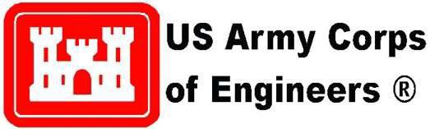

U.S. Army Corps of Engineers Resident Management System (RMS)
Software Maintenance Release

RMS Patch: PCF Database Update

March 23, 2021

Contents
1 Introduction 3
1.1 Overview 3
1.2 Contact 3
2 RMS GSA Contract Support Changes 3

Introduction

This document provides the details of the RMS application support changes to accommodate the requirement to send GSA contracts to PCF.

Overview

This release was implemented to support the capability for RMS to send GSA contracts to PCF.

Contact

If issues or concerns should arise, please contact the Help Desk.

  - Toll Free: 210-473-8658 – RMS Helpdesk Tech Support Center
  - Operation Hours: 24/7, excluding holidays.

RMS GSA Contract Support Changes

RMS supports sending various contract document numbering formats to PCF. RMS rules were modified to allow the transmission of GSA contracts. Three different types of contract numbers needed to be supported. Changes to the contract numbers are explained here: https://gsa.federalschedules.com/resources/anatomy-of-a-gsa-contract-number/

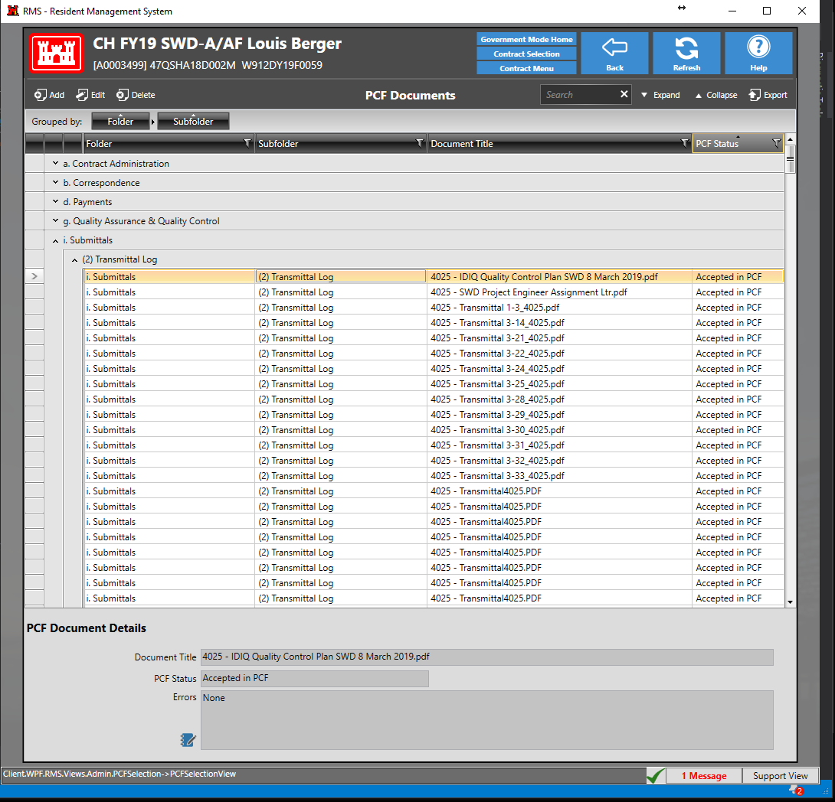
RMS was updated to allow the addition of 3 GSA Contract Number Types for Contract Documents to successfully be transferred to PCF.

GSA Contracts have 6 elements: (from gsa.federalschedules.com)
- Funding Agency Code
- Awarding Organization Code
- Organization Office Code
- Fiscal Year Awarded
- Type of “Instrument” (e.g. BPA, Task Order, IDIQ RFQ, or RFP)
- Number Unique to Your Contract Award
